OpenCAI: Open Cloud AI

Project report submitted for
Vth Semester Minor Project

in
Department of Computer Science and Engineering

By,
Atharva Bedekar (241000021)
Janay Bhanushali (241000035)
Sanidhya Solanki (241000070)


Department of Computer Science and Engineering
Dr. Shyama Prasad Mukherjee
International Institute of Information Technology, Naya Raipur
(A Joint Initiative of Govt. of Chhattisgarh and NTPC)
Email: iiitnr@iiitnr.ac.in, Tel: (0771) 2474040, Web: www.iiitnr.ac.in

CERTIFICATE

This is to certify that the project titled “OpenCAI: Open Cloud AI” by “Atharva Bedekar, Janay Bhanushali and Sanidhya Solanki” has been carried out under my/our supervision and that this work has not been submitted elsewhere for a degree.

(Signature of Guide)
___________________________________________
Dr. Ramakrishna Bandi
Position of Guide
Department of _________________
Dr. SPM IIIT-NR
October, 2026

Declaration

I declare that this written submission represents my ideas in my own words and where others' ideas or words have been included, I have adequately cited and referenced the original sources. I also declare that I have adhered to all principles of academic honesty and integrity and have not misrepresented or fabricated or falsified any idea/data/fact/source in my submission. I understand that any violation of the above will be cause for disciplinary action by the Institute and can also evoke penal action from the sources which have thus not been properly cited or from whom proper permission has not been taken when needed.

(Signature of Authors)
_________________
Atharva Bedekar, Janay Bhanushali, Sanidhya Solanki
(241000021, 241000035, 241000070)

Date : ___________________
PLAGARISM REPORT
(The plagiarism of the minor project report must be less the 10% for final acceptance of the report by panel members)

Approval Sheet

This project report entitled “OpenCAI: Open Cloud AI” by “Atharva Bedekar, Janay Bhanushali and Sanidhya Solanki” is approved for Vth Semester Minor Project.

(Signature of Examiner - I)
________________________
Name of Examiner -I

(Signature of Examiner - II)
________________________
Name of Examiner -II

(Signature of Chair)
________________________
Name of Chair
Date: ____________ Place: ____________

OpenCAI: Open Cloud AI
Atharva Bedekar, Janay Bhanushali, and Sanidhya Solanki
Abstract—Operating a cloud account requires detailed knowledge of provider consoles and command-line tools, and cost data is spread across many services. Large language model (LLM) agents can translate plain-language requests into commands, but allowing a model to execute commands on a live account is unsafe when the only safeguard is the model's own judgement. This report presents OpenCAI (Open Cloud AI), a self-hosted, white-label AIOps and FinOps platform in which Operators manage cloud resources by chatting with an AI agent. The agent proposes the exact AWS CLI command and explains it; a deterministic, default-deny command policy then classifies the command as a documentation lookup, a read-only operation, a mutating operation or a rejection. Read-only commands run immediately, mutating commands run only after the Operator explicitly confirms them, and everything executes inside an isolated, non-root Docker sandbox with credentials scoped to one Workspace. Administrators control Organisations, Workspaces, Operators, model settings and branding. Sign-in is protected by TOTP-based multi-factor authentication, cloud credentials are stored with AES-256-GCM envelope encryption, command output is sanitised for secrets, and every action is written to an audit log. The system is built with React, Node.js, Express, Prisma and PostgreSQL, supports five LLM providers, and is packaged with Docker Compose and an automated release pipeline. The backend test suite of 245 automated tests passes in full. Two guardrails, sandbox network egress restriction and spend-ceiling enforcement, remain as future work.
Impact Statement — Cloud operations and cost management are skill-intensive, and small teams often lack a dedicated cloud engineer. OpenCAI lets an Operator inspect resources, troubleshoot issues and analyse costs in plain language, while keeping a person in control of every change. Unlike vendor-hosted assistants, it can be self-hosted, re-branded by a managed-service provider, connected to the language model of the organisation's choice, and scoped so that each Operator reaches only the client Organisations assigned to them. Because safety is enforced by code around the model and not by the model, the approach offers a reusable pattern for building AI agents that act on real infrastructure: classify every action deterministically, require human approval for anything that changes state, isolate execution, and record everything.
Index Terms—AIOps, cloud computing, command policy, FinOps, human-in-the-loop, large language model agents, sandboxing.

Introduction
Public cloud platforms expose their services through web consoles and command-line interfaces (CLIs) with thousands of operations. Everyday tasks such as finding an idle resource, checking why an instance is unreachable, or explaining last month's bill require knowing which service, which operation and which flags to use. Two practices have grown around this complexity: AIOps, the use of artificial intelligence to support IT operations [4], and FinOps, a discipline for understanding and optimising cloud spend [5].
Large language models can now plan and call tools in a loop, the pattern popularised by ReAct [1]. This makes a conversational cloud operator feasible: the user states an intent, and the model works out and runs the commands. The same capability is a risk. A model can be wrong, and it can be manipulated by content it reads [2]; the OWASP Top 10 for LLM Applications lists both prompt injection and excessive agency among the main risks [3].
OpenCAI (Open Cloud AI) is a white-label AIOps and FinOps platform that addresses this. Operators chat with an agent to inspect resources, troubleshoot issues or analyse costs in a selected Workspace. The agent proposes the exact cloud command and explains it, and the platform runs it in an isolated Docker sandbox, after the Operator approves it if the command changes anything. Administrators decide which Organisations, cloud Workspaces and team members the platform can reach.

Motivation
The project is motivated by five issues observed in current practice. First, the skill barrier: consoles and CLIs are large, and plain language is faster than memorising syntax. Second, cost visibility: cost and usage data is spread across services, so waste and untagged resources go unnoticed. Third, control: an AI that runs commands on a live account must not act on its own judgement alone. Fourth, credentials: long-lived access keys shared between people and tools are a common source of leaks. Fifth, lock-in: available cloud assistants are tied to one vendor and cannot be self-hosted or re-branded [6].

Contributions
The major contributions of this work are the following.
1) A deterministic, default-deny command policy that sits between the model and the cloud. Every proposed command is parsed and classified in code as a lookup, a read-only operation, a mutating operation or a rejection.
2) A human-in-the-loop confirmation gate with a per-session cap, so that no command that changes resources runs without explicit approval.
3) A sandboxed execution layer: one short-lived, non-root Docker container per chat session, with credentials scoped to a single Workspace and never shown to the model.
4) A multi-tenant administration model (Organisation, Workspace, Operator) with TOTP multi-factor authentication, envelope-encrypted credentials and an independent audit log.
5) A provider-agnostic agent layer supporting five LLM providers, and a containerised, automatically versioned release.
The remainder of this report is organised as follows. Section III reviews related work. Section IV states the problem. Section V presents the proposed system. Section VI reports results, and Section VII concludes.

Literature Work
Table I summarises the work reviewed. It covers three strands: LLM agents and their security, operations and cost-management practice, and existing cloud assistants.
TABLE I
Summary of Reviewed Work
Reference | Technique used | Scope | Remarks / limitation
Yao et al. [1] | ReAct: an LLM loop that interleaves reasoning steps with tool actions | General agent tasks | No safety layer between the model and its actions
Greshake et al. [2] | Indirect prompt injection against LLM-integrated applications | Security analysis | Tool-using models can be steered by untrusted content; controls are needed outside the model
OWASP [3] | Risk catalogue including Prompt Injection and Excessive Agency | Industry guidance | Recommends least privilege and human approval; gives no reference implementation
Dang et al. [4] | Machine learning for incident and operations management | Large cloud services | Targets detection and diagnosis, not operator-driven command execution
FinOps Foundation [5] | Framework of phases (Inform, Optimize, Operate) and capabilities | Cloud cost management | A process framework; tooling is left to the practitioner
Amazon Q Developer [6] | Natural-language chat about AWS resources | AWS only | Vendor-hosted and single-cloud; cannot be self-hosted or white-labelled

Three research gaps follow from this review. 1) Safety is left to the model: agent frameworks have no deterministic check between a proposed action and its execution. 2) Assistants are vendor-tied: they are hosted by the provider, work on one cloud, and cannot be self-hosted, white-labelled or scoped per client organisation. 3) Operations and cost are separate: AIOps and FinOps tools are distinct products, with no single audited conversational interface covering both.

Problem Definition
Let a chat session be bound to a Workspace W, defined as the tuple (Organisation, Cloud Service Provider, Account, Environment), and to a mode m, which is AIOps or one of four FinOps sub-modes. Given an Operator message, an LLM produces either text or a proposed command c. The problem is to design a platform in which c reaches the cloud account only if all of the following hold: the binary invoked by c is on the allowlist for m; c contains no shell operators or command substitution; c is classified by deterministic code as a lookup, a read-only operation, or a mutating operation; and, if c is mutating, the Operator has explicitly confirmed the literal command and the session has not exceeded its cap of mutating commands.
Execution must take place outside the backend host, in an isolated environment that holds only the credentials of W. Credentials must never appear in the model prompt, and command output must be scrubbed of secrets before it is stored, shown or returned to the model. Every proposal, decision and outcome must be recorded independently of the chat transcript. The platform must be self-hosted, allow the LLM provider to be changed by configuration, and let an Administrator restrict each Operator to assigned Organisations. None of these properties may depend on the model behaving correctly.

Proposed Framework

Architecture
Fig. 1 shows the system. The browser runs a React single-page application built with Vite and Tailwind CSS, and talks only to the backend. The backend is a Node.js and Express API organised into isolated modules: authentication, administration, chat, and operator lookups. It stores data in PostgreSQL through Prisma, keeps branding assets in an S3-compatible store (MinIO), calls the configured LLM provider, and drives the Docker engine to run sandbox containers that hold the AWS CLI.
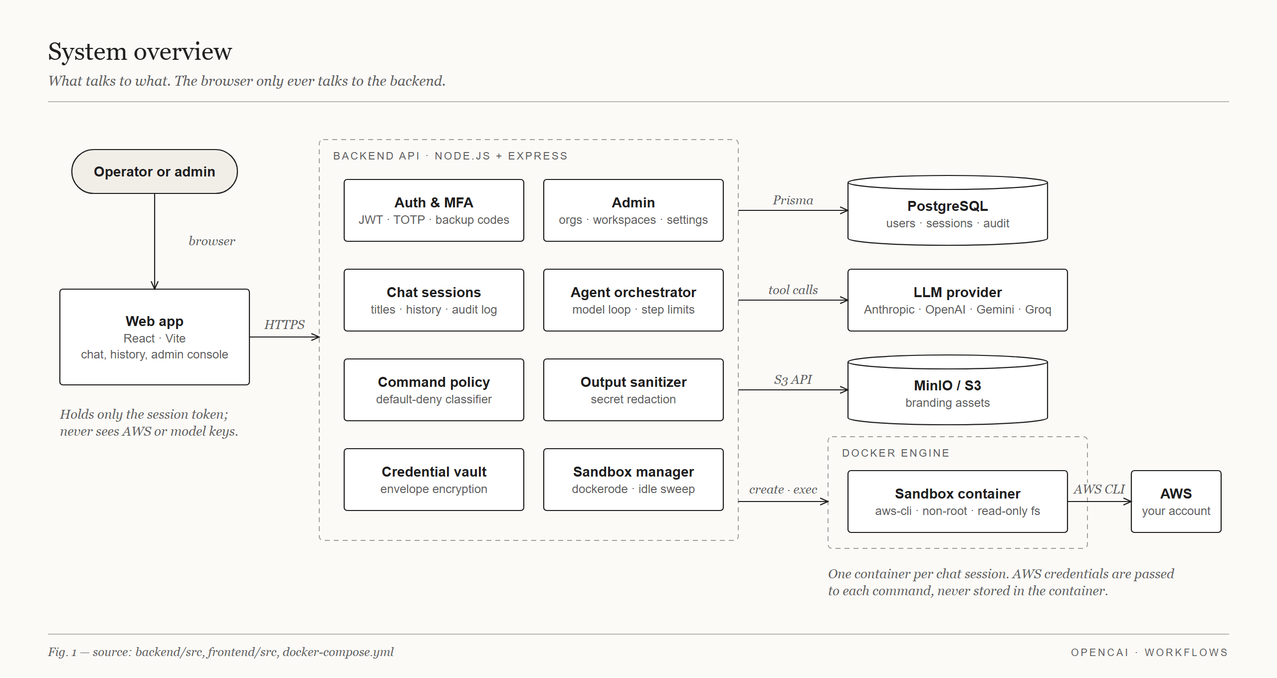
Fig. 1. System overview: the web application, backend modules, data stores, LLM provider and the Docker sandbox.

Agent Execution Flow
When an Operator sends a message, the chat module assembles the context (Organisation, Workspace, mode and history), ensures a sandbox exists for the session, and decrypts only the credential of the selected Workspace. The system prompt, or persona, for the mode is loaded from the database, so it can be tuned without a code change. The model is then called through a provider abstraction; adapters exist for Anthropic, OpenAI, Gemini, Groq and NVIDIA. The model answers with text or with a tool call that proposes a command. Results are sanitised and returned to the model, which either summarises them for the Operator or proposes the next command. Fig. 2 shows this loop.
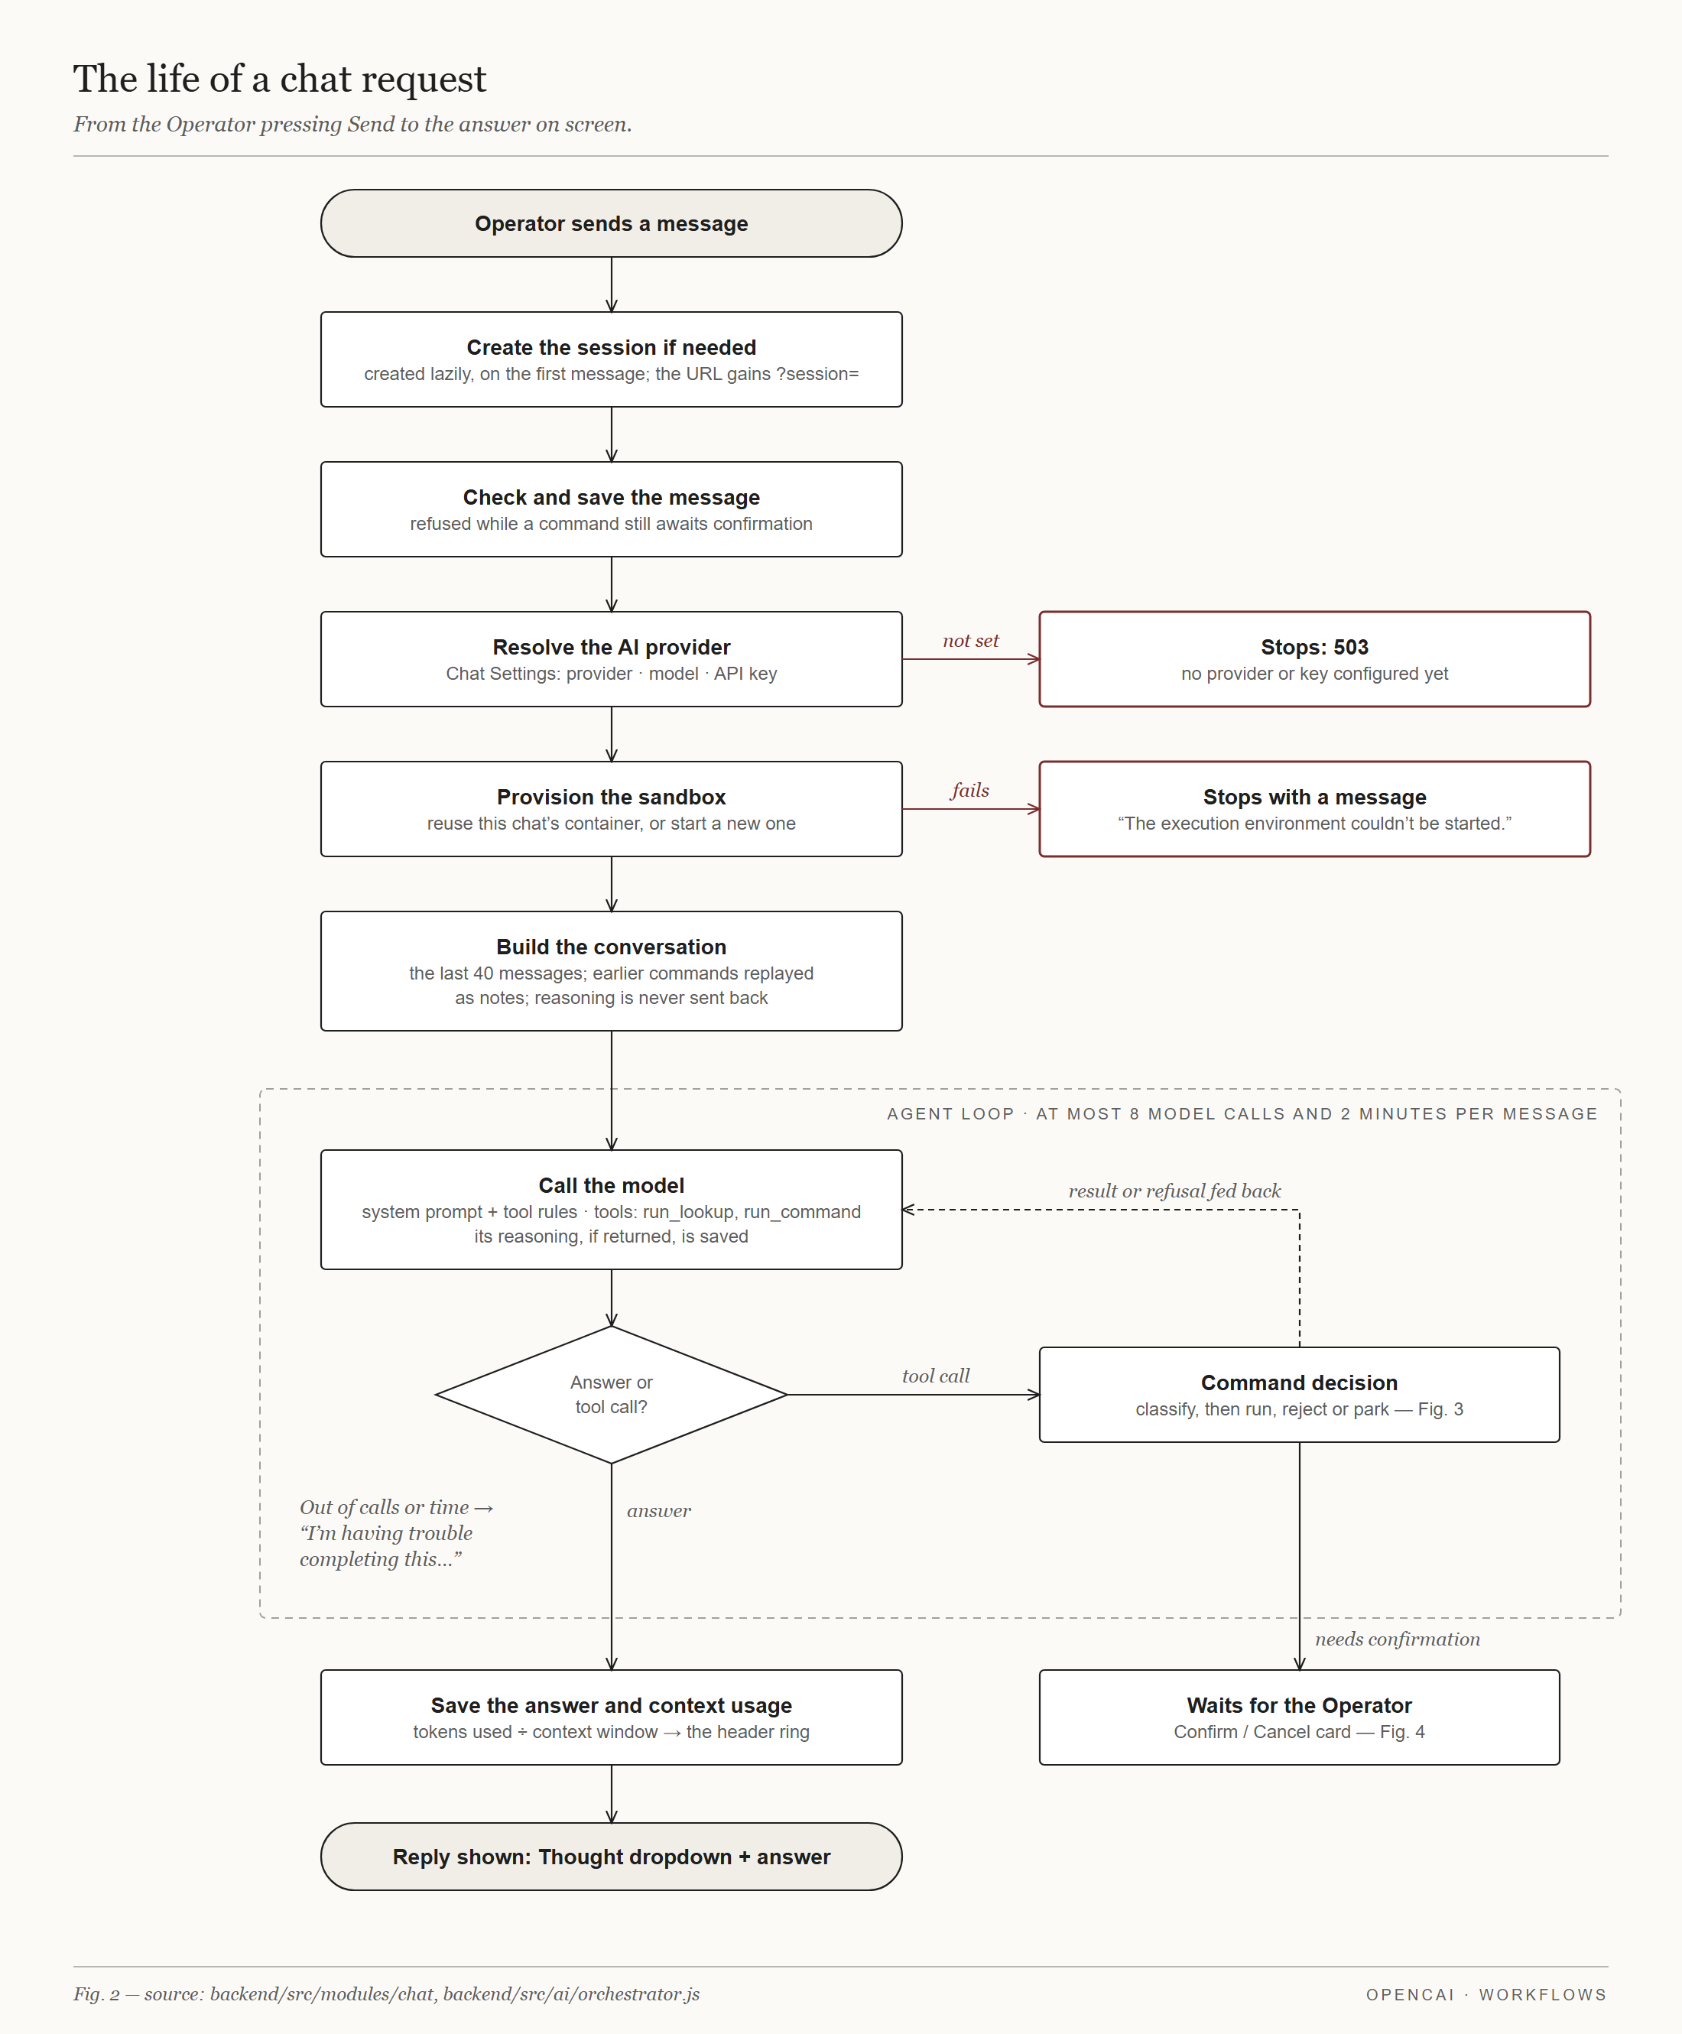
Fig. 2. The life of a chat request, including the agent loop and its limits.

Command Policy
Every proposed command passes the checks of Fig. 3, in order, before it can reach the sandbox. The policy is ordinary code, not a second model call, so a confused or manipulated model cannot talk its way past it. Anything not recognised as safe is rejected, and the reason is returned to the model. The procedure is given below.
function classify(command, persona):
args = tokenize(command) // shell-quote parser
if args is unparseable: return REJECT
if args contain && || | ; > < glob: return REJECT
if args contain backticks or $( ): return REJECT
if args[0] not in persona.allowedBinaries: return REJECT
if command is a --help / help request: return LOOKUP
if not "aws <service> <operation>": return REJECT
if operation changes resources: return NEEDS_CONFIRMATION
if operation is describe- / list- / get-: return READ_ONLY
return REJECT // default deny
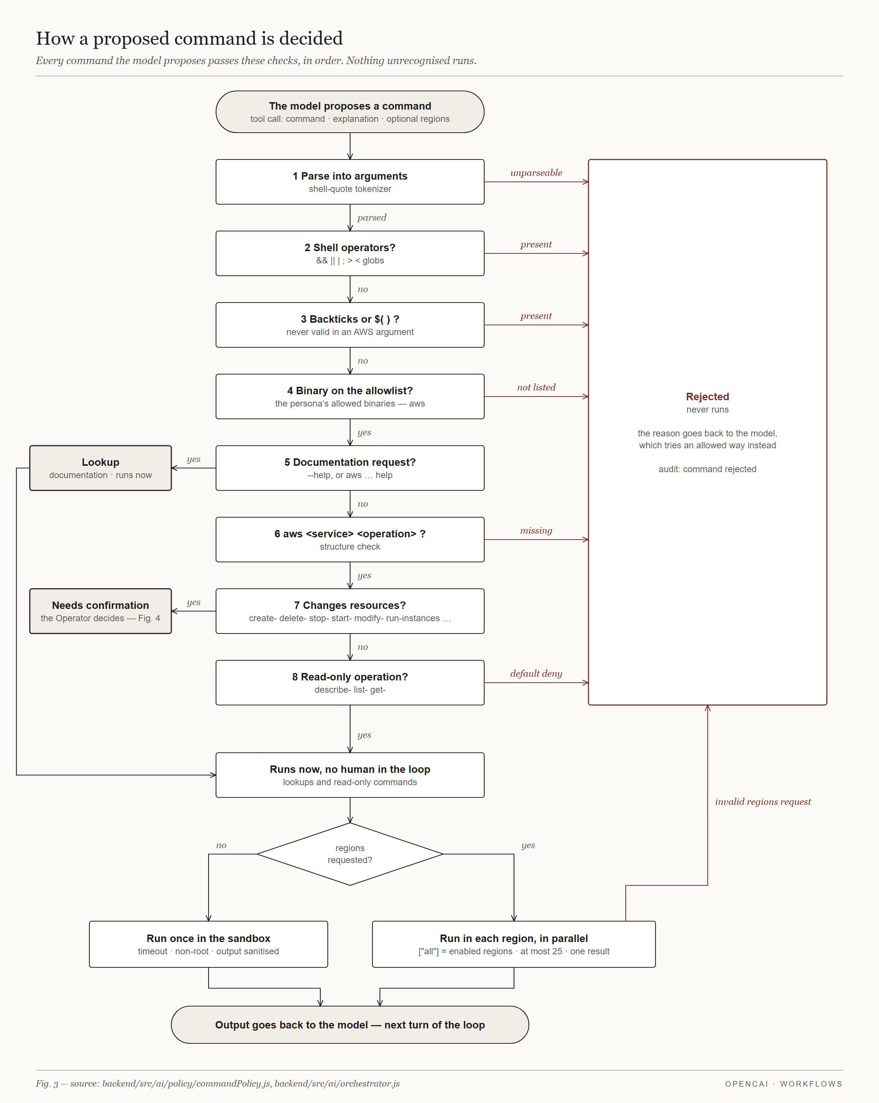
Fig. 3. How a proposed command is decided. Nothing unrecognised runs.

Confirmation and Execution
A command classified as mutating is never executed automatically. The chat shows the Operator the literal command and waits for Confirm or Cancel (Fig. 4). On confirmation, the backend checks the session cap of mutating commands (10 by default, configurable per persona) and then runs the command. Lookups and read-only commands run immediately. A read-only command may also be run across several regions in parallel, up to 25, returning one combined result.
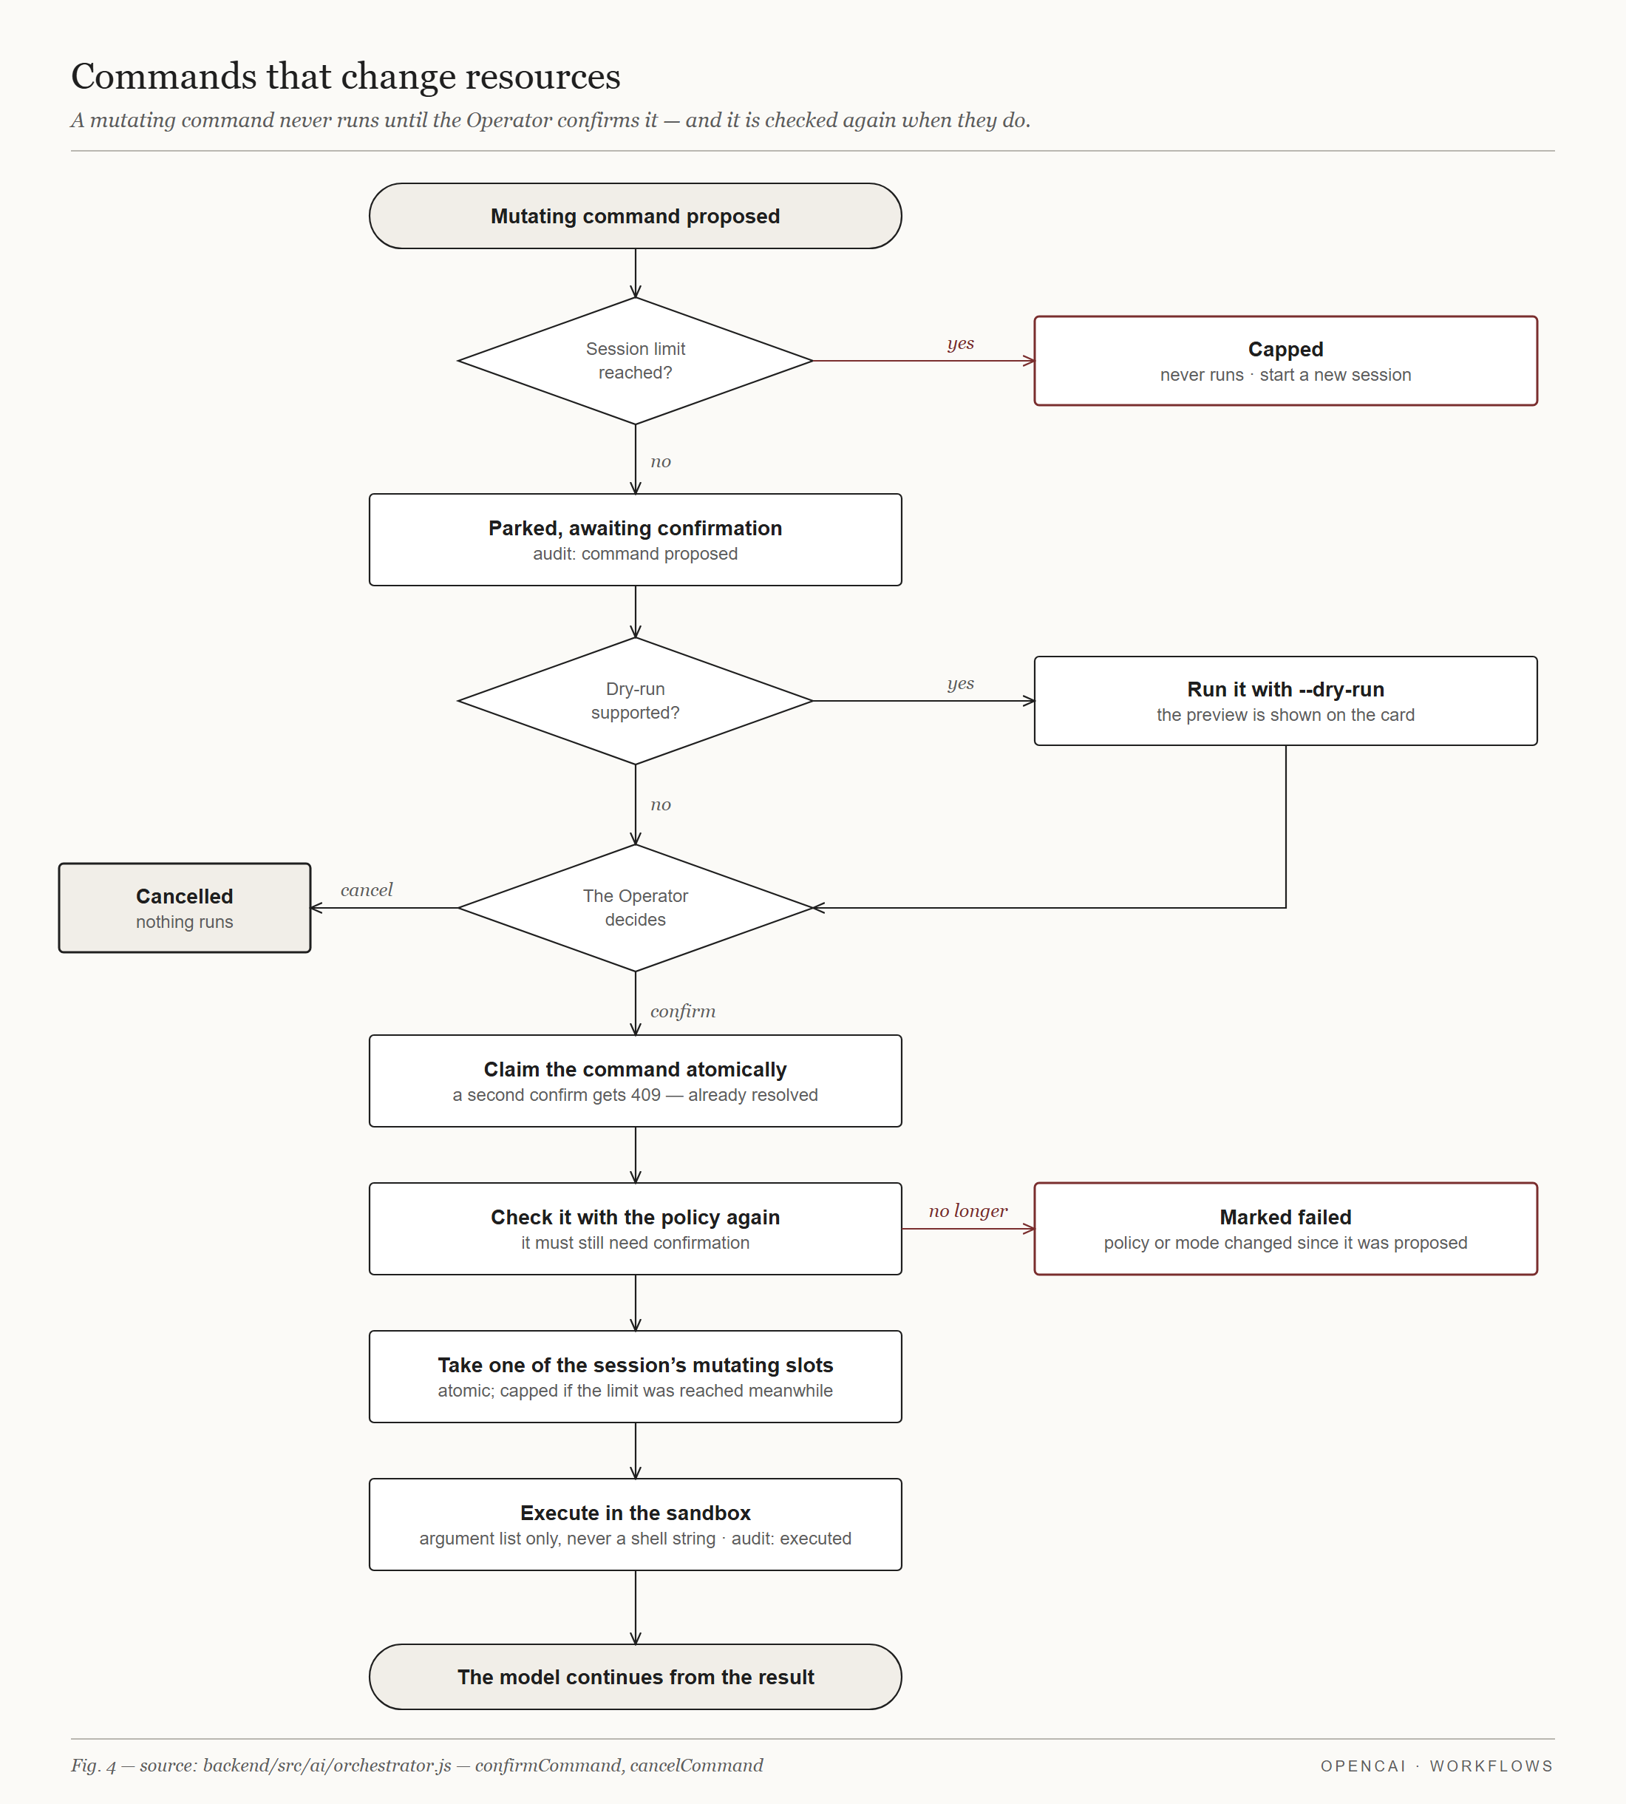
Fig. 4. Confirmation flow for commands that change resources.
Commands execute in a Docker container created per chat session from a version-pinned image that contains the AWS CLI. The container runs as a non-root user with a read-only file system. Credentials are passed to each command and are not stored in the container. Each command has a wall-clock timeout (60 s by default), output is capped, and idle sandboxes are removed (after 30 min by default). The output sanitiser redacts anything that looks like a secret before the output is stored, displayed or sent to the model.

Authentication and Credential Protection
Sign-in uses a username and password followed by a time-based one-time password (TOTP) [7]. On first sign-in the user enrols by scanning a QR code; one-time backup codes are issued and stored hashed. A JSON Web Token is issued only after both factors succeed (Fig. 5). Cloud credentials, the TOTP secret and the LLM provider key are stored with envelope encryption: each value is encrypted with AES-256-GCM under a data key, which is wrapped by a master key supplied through the environment.
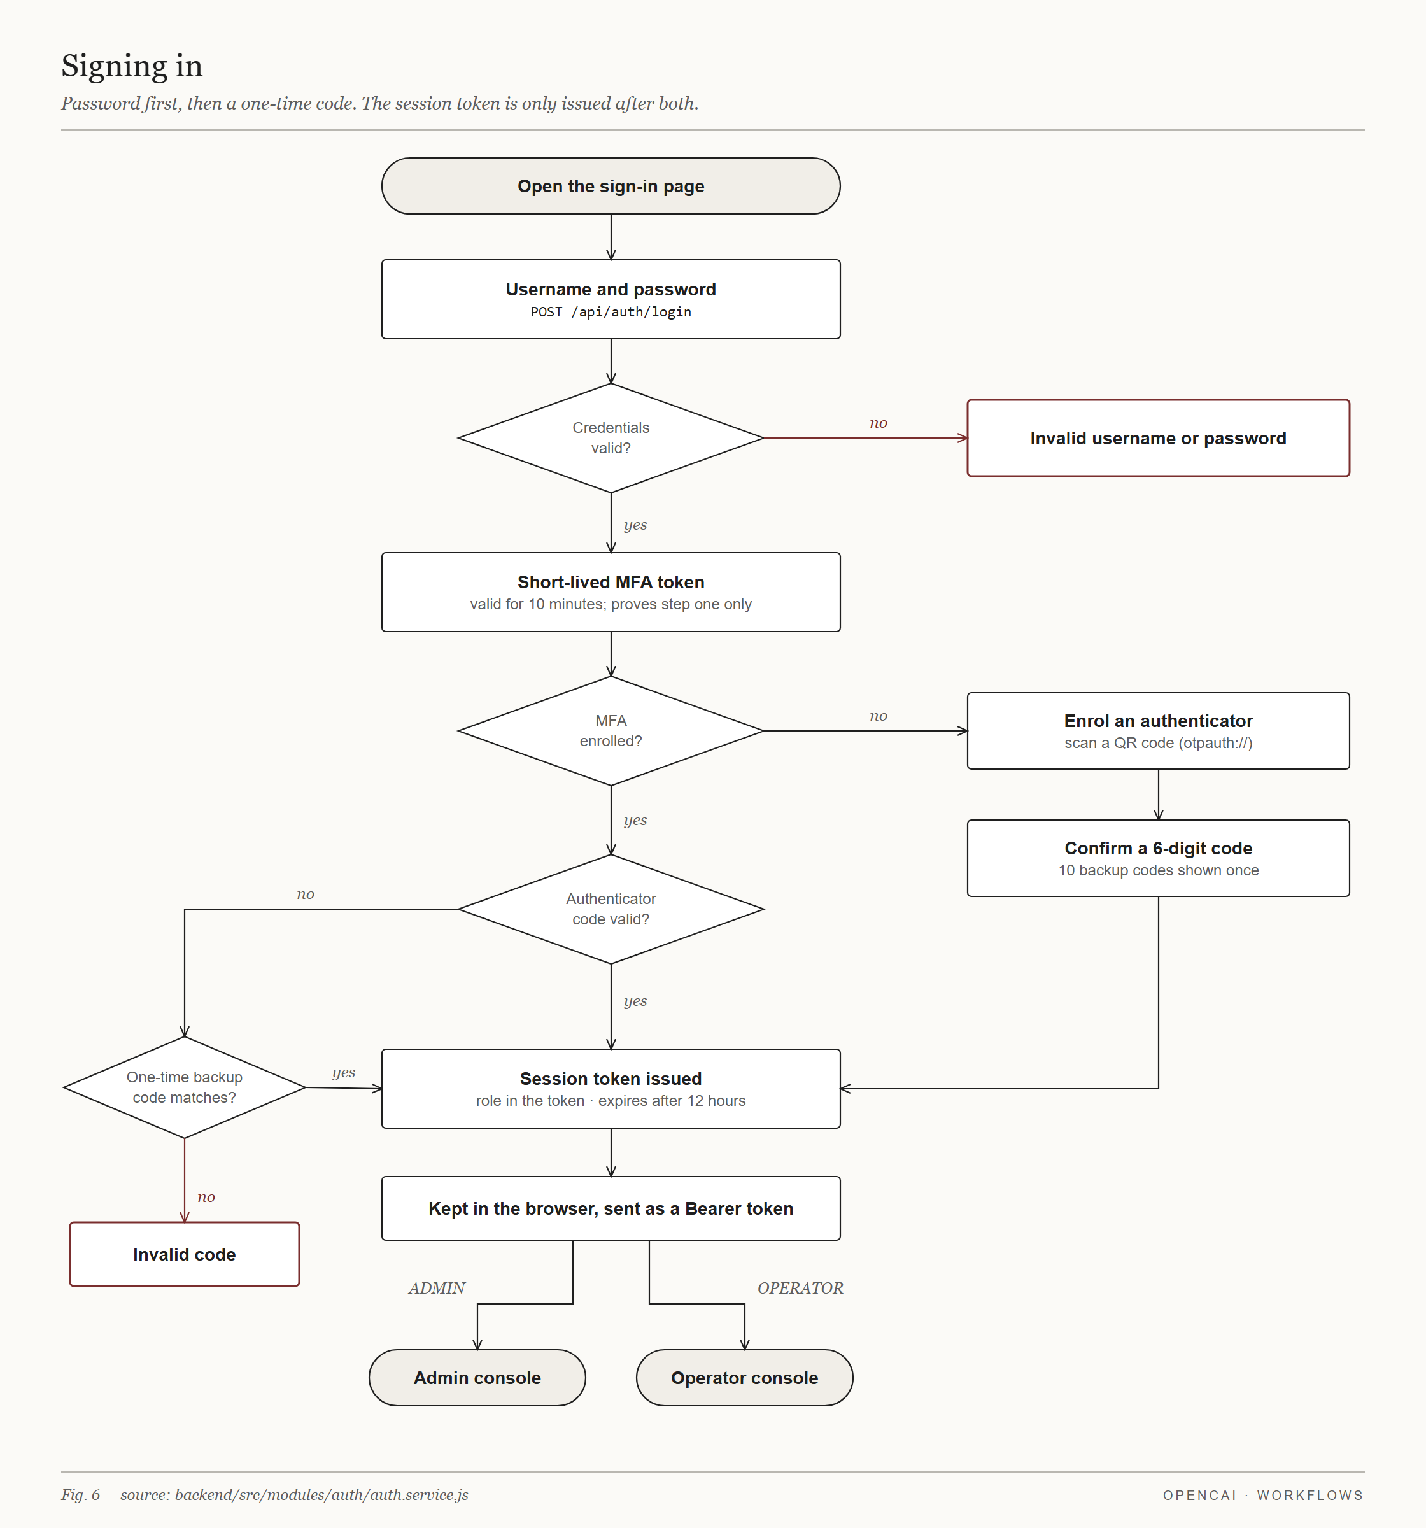
Fig. 5. Sign-in with password, MFA enrolment and verification, and backup codes.

Data Model
The database has eleven Prisma models, listed in Table II. No external dataset is used; the system stores its own operational data. The audit log is independent of chat history: if a user, Workspace or session is removed, the log entry remains with the reference set to null.
TABLE II
Data Model
Model | Purpose | Key fields
User | Administrator or Operator account | role, passwordHash, totpSecretEncrypted, backupCodesHashed
Organisation, UserOrganisation | Client business; which Operators may access it | name, address, phone; userId, organisationId
Workspace | Organisation, cloud provider, account and environment | csp, account, environment, isActive
WorkspaceCredential | Cloud access keys for one Workspace | encryptedCredentials
ChatSettings | Selected provider, model and limits | provider, model, sandbox timeouts, spendCeilingUsd
AgentPersona | System prompt per mode or sub-mode | modeKey, systemPrompt, allowedBinaries
ChatSession | One conversation in a Workspace | mode, subMode, sandbox state, mutatingCommandCap, mutatingCommandCount
ChatMessage | Every message, command and result | role, kind, content, commandOutput, status
AuditLog | Independent record of every action | actor, workspace, action, outcome, metadata
InstanceBranding | White-label name, logo and login image | displayName, logoObjectKey, loginImageObjectKey

Packaging and Release
A Docker Compose file runs the frontend, backend, PostgreSQL and MinIO together. Work lands on a dev branch and reaches a protected release branch by pull request. On merge, a GitHub Actions workflow runs semantic-release to compute the next version from Conventional Commit messages, tags it, and publishes backend and frontend images to the GitHub Container Registry.

Experimental Result and Discussion

Setup
The backend is tested with the built-in Node.js test runner. External dependencies (the database client, the Docker engine and the LLM providers) are replaced by test doubles, so the tests exercise the platform's own logic. The application was also run locally against PostgreSQL and MinIO.

Test Results
The suite contains 245 tests in 21 files. In the run recorded for this report, all 245 passed and none failed, in about 15 s. Table III lists the areas covered.
TABLE III
Backend Test Coverage by Area (245 Tests, All Passing)
Area | What is verified
Command policy | Rejection of shell operators, command substitution and non-allowlisted binaries; lookup, read-only and mutating classification; default deny
Output sanitiser | Redaction of secret-like values; fails closed on non-string input
Sandbox manager | Container creation and reuse, non-root execution, timeouts, output cap, fail-closed execution
Agent orchestrator | The model loop, step limits, confirmation and cancellation of pending commands, recovery from failures
Provider adapters | Request and response mapping for Anthropic, OpenAI, Gemini, Groq and NVIDIA
Crypto and credentials | Envelope encryption round trip; credential handling
Admin services | Administrators, Operators, Workspaces, personas, chat settings, chat oversight; protected master admin; MFA reset
Chat service | Session ownership, deactivated Workspaces, missing credentials, pending-confirmation conflicts, session caps and titles

Application
The application was exercised against an AWS Workspace. Fig. 6 shows the sign-in screen with the instance branding applied, and Fig. 7 the Administrator dashboard. In the AIOps session of Fig. 8 the Operator asked for the status of instances in the ap-south-1 region; the agent ran one read-only command and returned the result as a table. Later in the same session the Operator asked to stop the instance. Fig. 9 shows the expanded step: the agent notes that the operation is mutating and needs Operator confirmation, proposes the literal stop-instances command, and the command is marked as executed. Fig. 10 shows the FinOps agent selection and Fig. 11 a Cost Analytics session that queried AWS Cost Explorer.
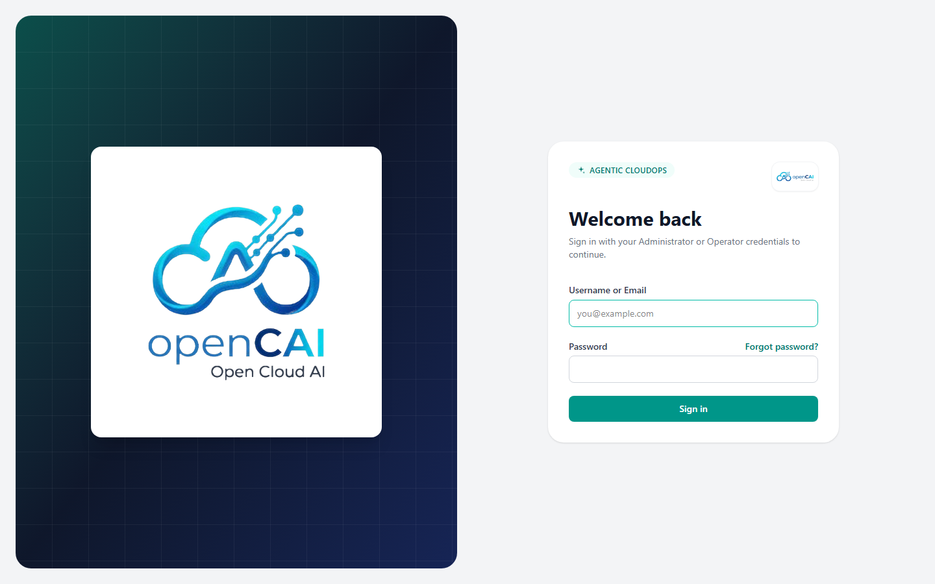
Fig. 6. OpenCAI sign-in screen (local run).
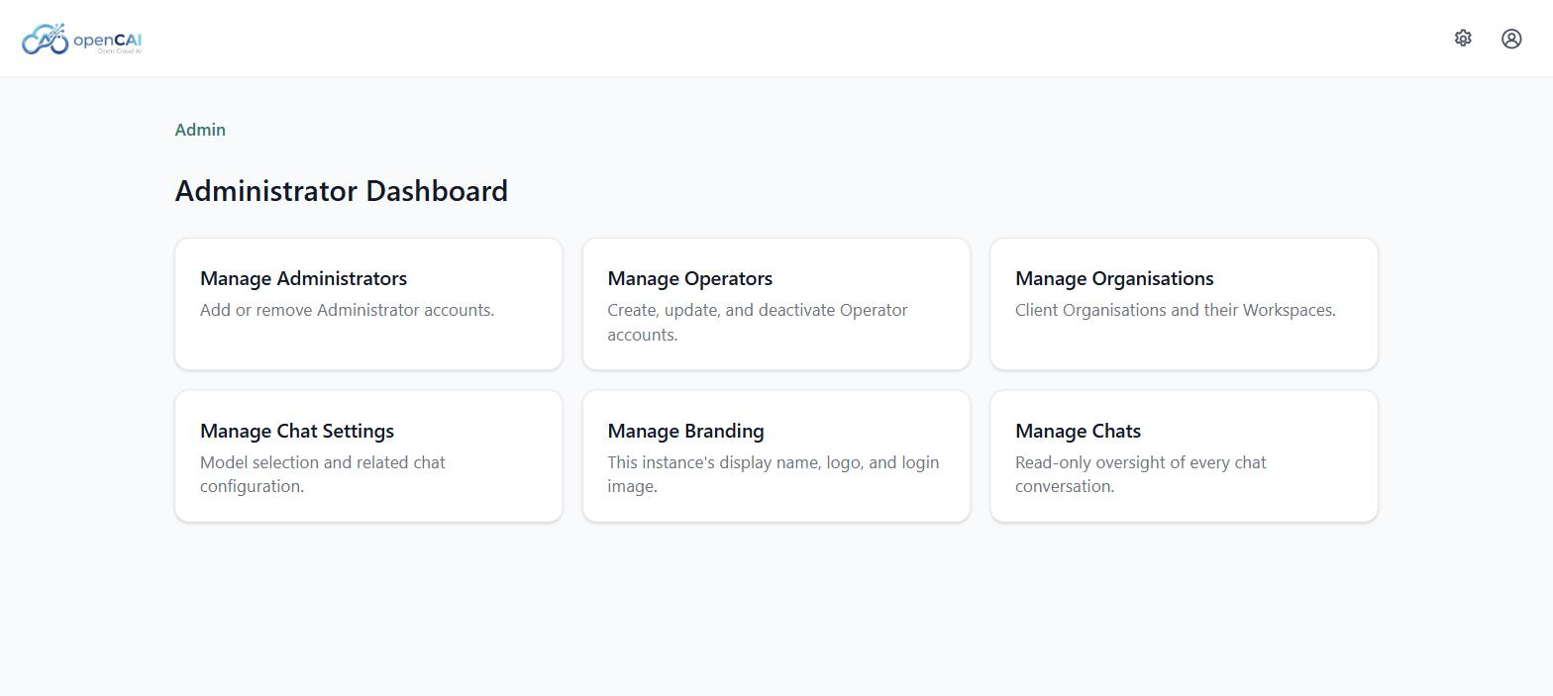
Fig. 7. Administrator dashboard.
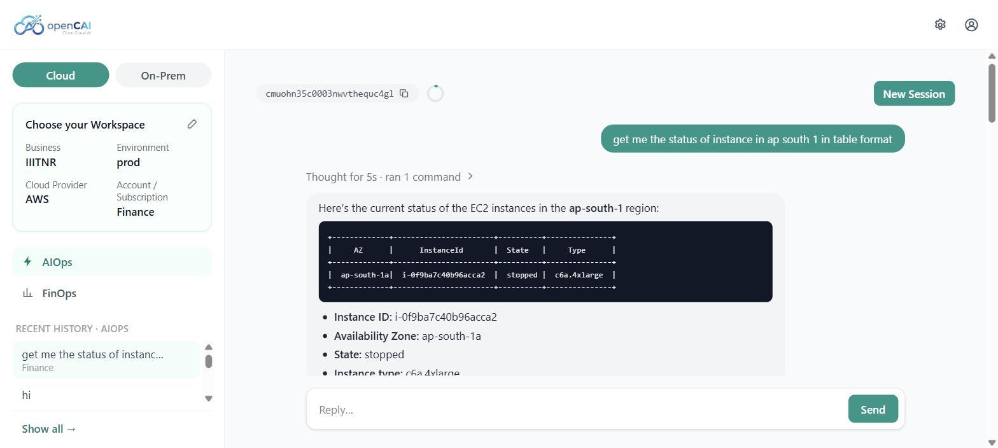
Fig. 8. AIOps session: a read-only command and its result.
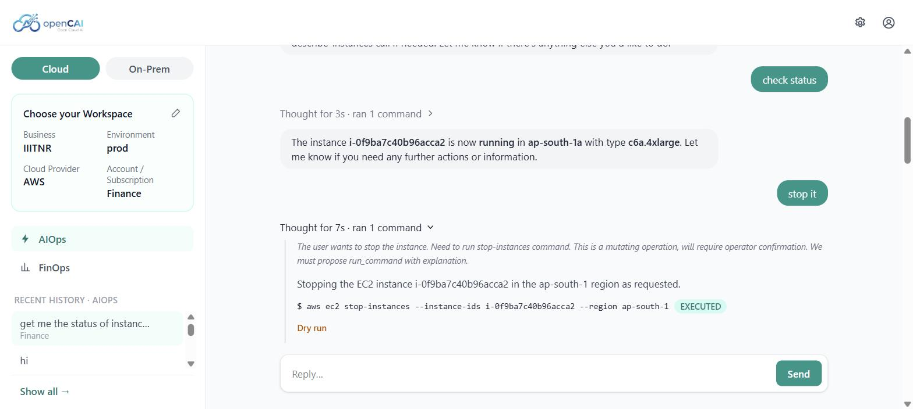
Fig. 9. A mutating command (stop-instances) proposed by the agent and marked as executed.
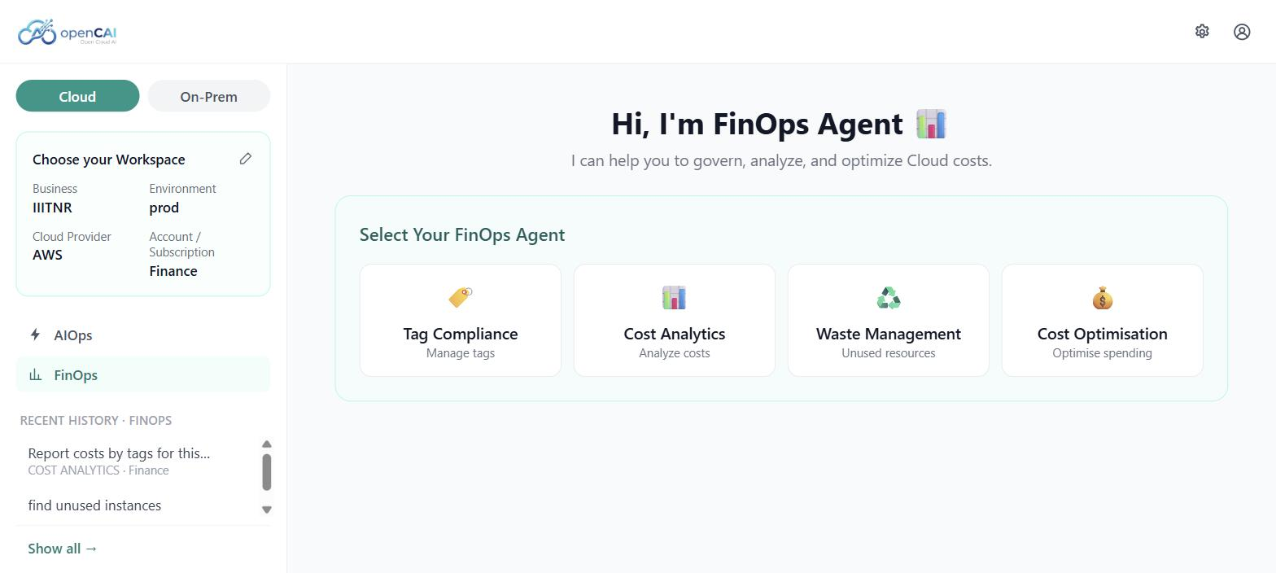
Fig. 10. FinOps mode with its four sub-mode agents.
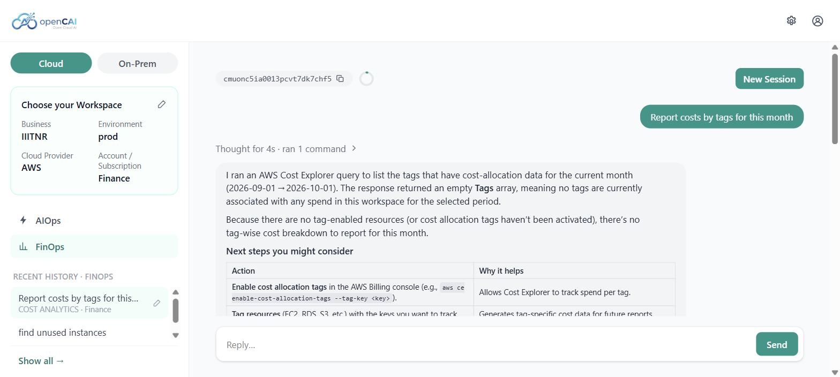
Fig. 11. FinOps Cost Analytics session using AWS Cost Explorer.

Discussion and Limitations
The tests confirm that the safety properties are enforced in code: a command that is not recognised does not run, and a mutating command does not run without confirmation. Two guardrails are not yet complete. First, the sandbox runs on Docker's default bridge network and therefore has general outbound access; restricting egress to the cloud provider's API endpoints is still required. Second, the session cap on the number of mutating commands is enforced, but the administrator-configurable spend ceiling is stored and not yet checked, because no real-time cost estimation exists. The platform currently supports AWS only, and no user study or performance benchmark has been carried out.

Conclusion and Future Directions
OpenCAI shows that a conversational agent can operate a cloud account without the model being trusted to be safe. Operators work in plain language, while a default-deny policy, human confirmation, sandboxed execution, output sanitisation and an audit trail constrain what can happen. The platform is self-hosted, white-label, provider-agnostic and released automatically. Future work is to restrict sandbox network egress, enforce the spend ceiling with cost estimation, add further cloud providers and the on-premises mode, and evaluate the system more widely on live accounts.

Acknowledgment
The authors thank Dr. Ramakrishna Bandi for supervision and guidance throughout this project.

References
- S. Yao, J. Zhao, D. Yu, N. Du, I. Shafran, K. Narasimhan, and Y. Cao, "ReAct: Synergizing reasoning and acting in language models," in Proc. Int. Conf. Learn. Represent. (ICLR), 2023. [Online]. Available: https://arxiv.org/abs/2210.03629
- K. Greshake, S. Abdelnabi, S. Mishra, C. Endres, T. Holz, and M. Fritz, "Not what you've signed up for: Compromising real-world LLM-integrated applications with indirect prompt injection," in Proc. 16th ACM Workshop Artif. Intell. Secur. (AISec), 2023, pp. 79-90.
- OWASP Foundation, "OWASP Top 10 for LLM Applications 2025." Accessed on: Oct. 4, 2026. [Online]. Available: https://genai.owasp.org/llm-top-10/
- Y. Dang, Q. Lin, and P. Huang, "AIOps: Real-world challenges and research innovations," in Proc. IEEE/ACM 41st Int. Conf. Softw. Eng.: Companion (ICSE-Companion), 2019, pp. 4-5.
- FinOps Foundation, "FinOps Framework." Accessed on: Oct. 4, 2026. [Online]. Available: https://www.finops.org/framework/
- Amazon Web Services, "What is Amazon Q Developer?," Amazon Q Developer User Guide. Accessed on: Oct. 4, 2026. [Online]. Available: https://docs.aws.amazon.com/amazonq/latest/qdeveloper-ug/what-is.html
- D. M'Raihi, S. Machani, M. Pei, and J. Rydell, "TOTP: Time-based one-time password algorithm," RFC 6238, Internet Eng. Task Force, May 2011.
- Docker Inc., "Docker Engine security." Accessed on: Oct. 4, 2026. [Online]. Available: https://docs.docker.com/engine/security/

